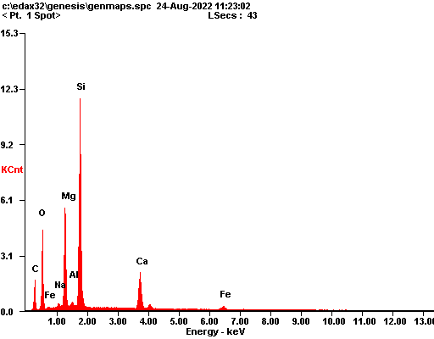

|  |  |  |
| --- | --- | --- |
| ***Element*** | ***Wt%*** | ***At%*** |
| ***CK*** | 18.19 | 30.51 |
| ***OK*** | 23.90 | 30.09 |
| ***NaK*** | 00.60 | 00.53 |
| ***MgK*** | 12.92 | 10.70 |
| ***AlK*** | 00.65 | 00.48 |
| ***SiK*** | 29.14 | 20.90 |
| ***CaK*** | 10.75 | 05.40 |
| ***FeK*** | 03.84 | 01.38 |
| ***Matrix*** | Correction | ZAF |

